 | DOKUZ EYLUL UNIVERSITY  ENGINEERING FACULTY  DEPARTMENT OF COMPUTER ENGINEERING | 

CME1214 LOGIC DESIGN
PRELIMINARY REPORT

LAB 2

by
Mesut Selim Serbes
2017510100

Lecturers
Instructor Dr. Özlem Öztürk
Res.Asst. Dr. Feriştah Dalkılıç
Res.Asst. Özlem Yerlikaya
Res.Asst. Gökmen Katipoğlu

IZMIR
25.03.2019
      - TRUTH TABLE
1.Experiment
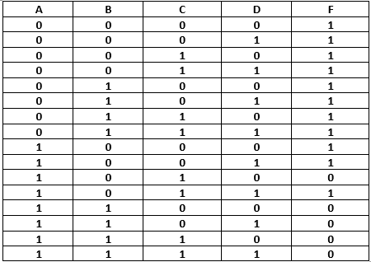
2.Experiment
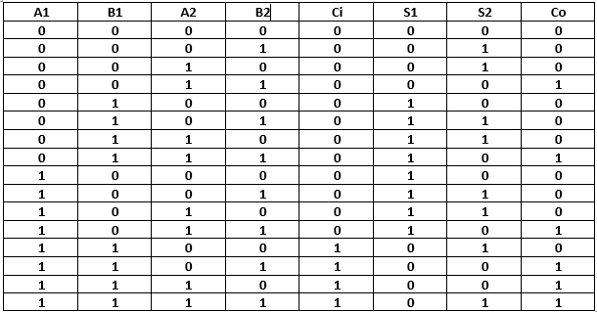

      - KARNAUGH MAPS
1.Experiment
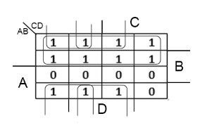
2.Experiment
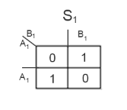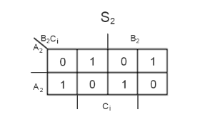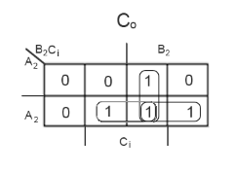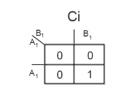
      - LOGIC DIAGRAM
1.Experiment
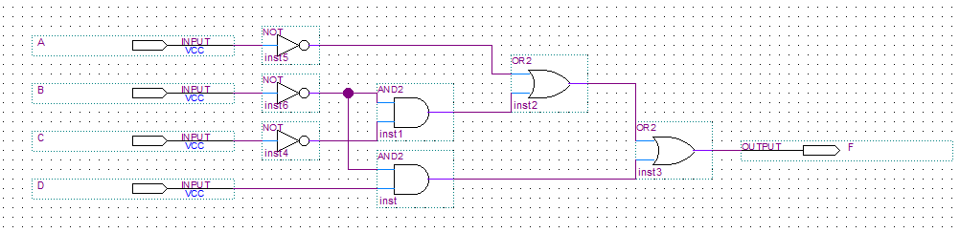

2.Experiment
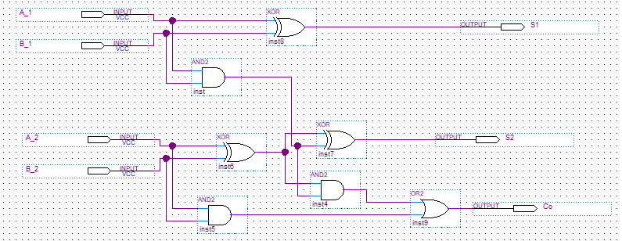
      - WAVEFORMS
1.Experiment
Functional Waveform

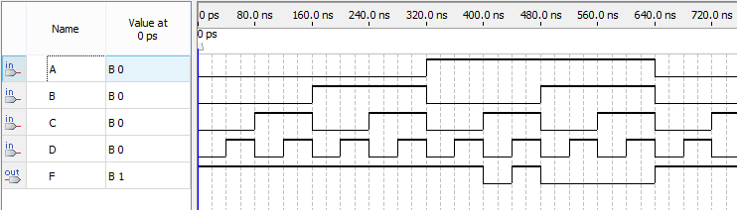
Timing Waveform

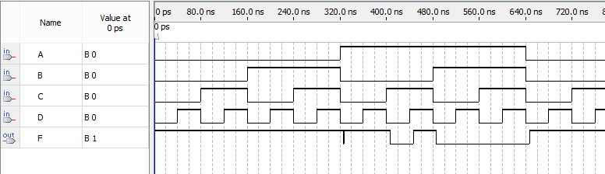

2.Experiment
Functional Waveform

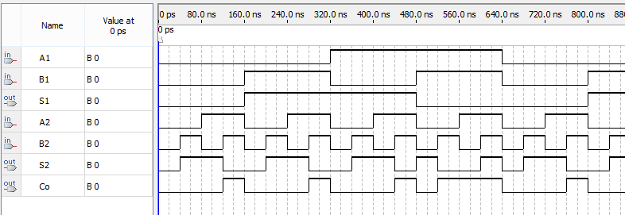
Timing Waveform

